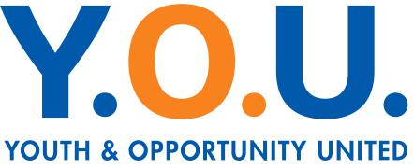
Planned Gift Commitment Form
Y.O.U. Legacy Partners was established to continue to provide a way for our most dedicated supporters to join us in creating lasting support for our youth. Thank you for partnering with Y.O.U. in uniting the past and the future by building a legacy that will carry on through future generations.
____________________________________________________________________________
Name(s)

____________________________________________________________________________
Street Address, city, state and postal code

____________________________________________________________________________
Phone Number Email address

Planned Gift Details:
- Bequest through a will or trust Retirement plan beneficiary
- Life insurance policy beneficiary Other ______________________
The estimated value of my planned gift is ($)_________________________ (optional)
Recognition:
Y.O.U. honors the generosity and dedication of Legacy Partners publicly in our annual report and in the lobby of our facility on our (insert name).
- Y.O.U. has permission to include my/our names in public Legacy Partners recognition.
- I/We wish to remain anonymous.
____________________________________________________________________________
Name(s) as you would like to appear in recognition (please print)

Please share with us what motivated you to make this special gift to Y.O.U.:
_____________________________________________________________________________
_____________________________________________________________________________

_____________________________________________________________________________
Signature(s) Date

Please return this form and any attachments to: Y.O.U. Advancement Officer Krysta Michorczyk at kmichorczyk@youthopportunity.org OR Youth & Opportunity United, c/o Krysta Michorczyk, 1911 Church Street, Evanston, IL, 60201

